UNITED STATES
SECURITIES AND EXCHANGE COMMISSION
Washington, D.C. 20549
FORM 8-K
CURRENT REPORT
Pursuant to Section 13 OR 15(d)
of The Securities Exchange Act of 1934
Date of Report (Date of earliest event reported): August 5, 2026
Context Therapeutics Inc.
(Exact name of registrant as specified in its charter)
Delaware |  |  | 001-40654 |  |  | 86-3738787
(State or other jurisdiction of incorporation) |  |  | (Commission File Number) |  |  | (I.R.S. Employer Identification No.)
2001 Market Street, Suite 3915, Unit #15
Philadelphia, Pennsylvania 19103
(Address of principal executive offices including zip code)
(267) 225-7416
(Registrant’s telephone number, including area code)
Not Applicable
(Former name or former address, if changed since last report)
Check the appropriate box below if the Form 8-K filing is intended to simultaneously satisfy the filing obligation of the registrant under any of the following provisions:
☐ Written communications pursuant to Rule 425 under the Securities Act (17 CFR 230.425)
☐ Soliciting material pursuant to Rule 14a-12 under the Exchange Act (17 CFR 240.14a-12)
☐ Pre-commencement communications pursuant to Rule 14d-2(b) under the Exchange Act (17 CFR 240.14d-2(b))
☐ Pre-commencement communications pursuant to Rule 13e-4(c) under the Exchange Act (17 CFR 240.13e-4(c))
Securities registered pursuant to Section 12(b) of the Act:
Title of each class |  |  |  |  |  | Trading  Symbol(s) |  |  |  |  |  | Name of each exchange  on which registered
Common Stock |  |  |  |  |  | CNTX |  |  |  |  |  | The Nasdaq Stock Market
$0.001 par value per share
Indicate by check mark whether the registrant is an emerging growth company as defined in Rule 405 of the Securities Act of 1933 (§230.405 of this chapter) or Rule 12b-2 of the Securities Exchange Act of 1934 (§240.12b-2 of this chapter).
Emerging growth company ☒
If an emerging growth company, indicate by check mark if the registrant has elected not to use the extended transition period for complying with any new or revised financial accounting standards provided pursuant to Section 13(a) of the Exchange Act. ☐

Item 7.01. Regulation FD Disclosure.
On August 5, 2026, Context Therapeutics Inc. (the "Company") updated its corporate presentation for use in meetings with investors, analysts and others. A copy of the corporate presentation is filed as Exhibit 99.1 to this Current Report on Form 8-K and incorporated herein by reference.

The information in this Item 7.01, and Exhibit 99.1 attached hereto, are being furnished and shall not be deemed “filed” for the purposes of Section 18 of the Securities Exchange Act of 1934, as amended (the "Exchange Act"), or otherwise subject to the liabilities of that section, nor shall it be deemed incorporated by reference in any filing under the Securities Act of 1933, as amended, or the Exchange Act, regardless of any general incorporation language in such filing.

Item 9.01. Financial Statements and Exhibits.
(d) Exhibits
Exhibit No. |  |  |  |  |  | Description
99.1 |  |  |  |  |  | Context Therapeutics Inc. Corporate Presentation — August 2026
104 |  |  |  |  |  | Cover Page Interactive Data File (embedded within the inline XBRL document)

SIGNATURES
Pursuant to the requirements of the Securities Exchange Act of 1934, the registrant has duly caused this report to be signed on its behalf by the undersigned hereunto duly authorized.
Dated: August 5, 2026 |  |  | Context Therapeutics Inc.
 |  |  | By: |  |  | /s/ Martin A. Lehr
 |  |  |  |  |  | Name: Martin A. Lehr
 |  |  |  |  |  | Title: Chief Executive Officer
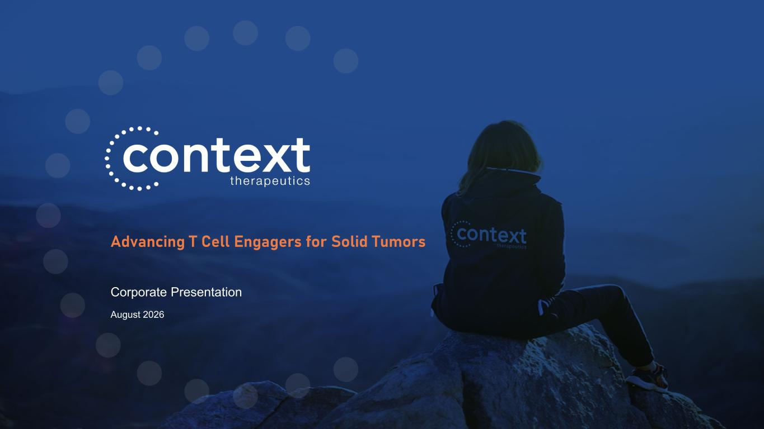

August 2026 Corporate Presentation Advancing T Cell Engagers for Solid Tumors

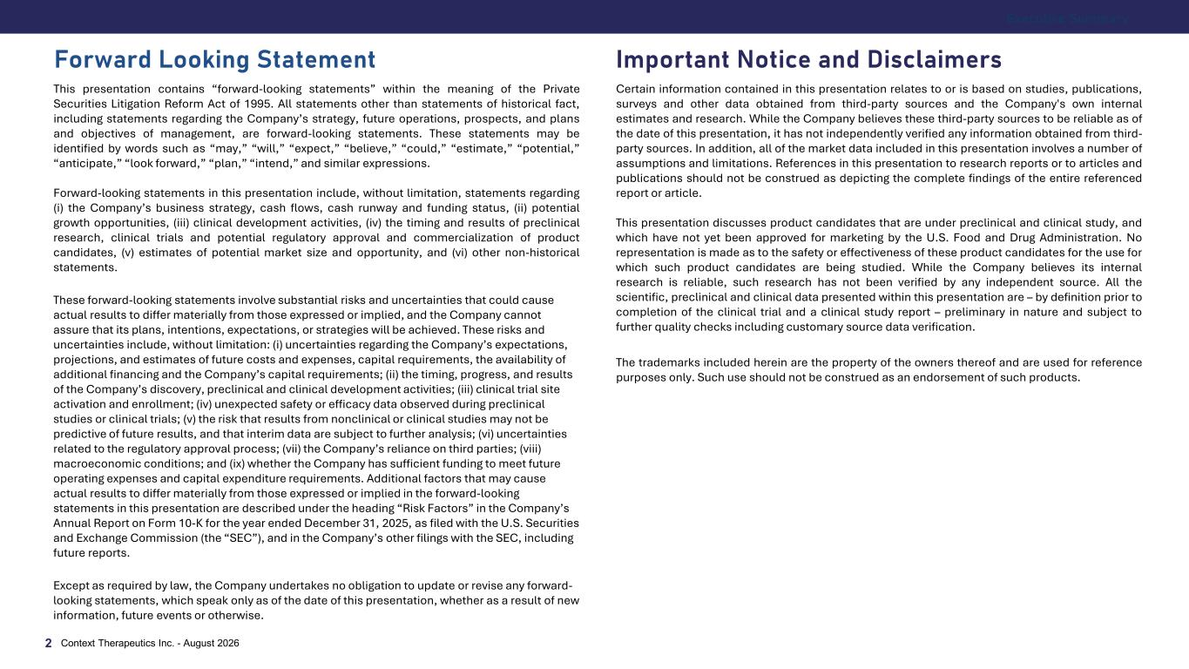
Important Notice and Disclaimers This presentation contains “forward-looking statements” within the meaning of the Private Securities Litigation Reform Act of 1995. All statements other than statements of historical fact, including statements regarding the Company’s strategy, future operations, prospects, and plans and objectives of management, are forward-looking statements. These statements may be identified by words such as “may,” “will,” “expect,” “believe,” “could,” “estimate,” “potential,” “anticipate,” “look forward,” “plan,” “intend,” and similar expressions. Forward-looking statements in this presentation include, without limitation, statements regarding (i) the Company’s business strategy, cash flows, cash runway and funding status, (ii) potential growth opportunities, (iii) clinical development activities, (iv) the timing and results of preclinical research, clinical trials and potential regulatory approval and commercialization of product candidates, (v) estimates of potential market size and opportunity, and (vi) other non-historical statements. These forward-looking statements involve substantial risks and uncertainties that could cause actual results to differ materially from those expressed or implied, and the Company cannot assure that its plans, intentions, expectations, or strategies will be achieved. These risks and uncertainties include, without limitation: (i) uncertainties regarding the Company’s expectations, projections, and estimates of future costs and expenses, capital requirements, the availability of additional financing and the Company’s capital requirements; (ii) the timing, progress, and results of the Company’s discovery, preclinical and clinical development activities; (iii) clinical trial site activation and enrollment; (iv) unexpected safety or efficacy data observed during preclinical studies or clinical trials; (v) the risk that results from nonclinical or clinical studies may not be predictive of future results, and that interim data are subject to further analysis; (vi) uncertainties related to the regulatory approval process; (vii) the Company’s reliance on third parties; (viii) macroeconomic conditions; and (ix) whether the Company has sufficient funding to meet future operating expenses and capital expenditure requirements. Additional factors that may cause actual results to differ materially from those expressed or implied in the forward-looking statements in this presentation are described under the heading “Risk Factors” in the Company’s Annual Report on Form 10-K for the year ended December 31, 2025, as filed with the U.S. Securities and Exchange Commission (the “SEC”), and in the Company’s other filings with the SEC, including future reports. Except as required by law, the Company undertakes no obligation to update or revise any forward- looking statements, which speak only as of the date of this presentation, whether as a result of new information, future events or otherwise. Certain information contained in this presentation relates to or is based on studies, publications, surveys and other data obtained from third-party sources and the Company's own internal estimates and research. While the Company believes these third-party sources to be reliable as of the date of this presentation, it has not independently verified any information obtained from third- party sources. In addition, all of the market data included in this presentation involves a number of assumptions and limitations. References in this presentation to research reports or to articles and publications should not be construed as depicting the complete findings of the entire referenced report or article. This presentation discusses product candidates that are under preclinical and clinical study, and which have not yet been approved for marketing by the U.S. Food and Drug Administration. No representation is made as to the safety or effectiveness of these product candidates for the use for which such product candidates are being studied. While the Company believes its internal research is reliable, such research has not been verified by any independent source. All the scientific, preclinical and clinical data presented within this presentation are – by definition prior to completion of the clinical trial and a clinical study report – preliminary in nature and subject to further quality checks including customary source data verification. The trademarks included herein are the property of the owners thereof and are used for reference purposes only. Such use should not be construed as an endorsement of such products. Forward Looking Statement Executive Summary Context Therapeutics Inc. - August 20262

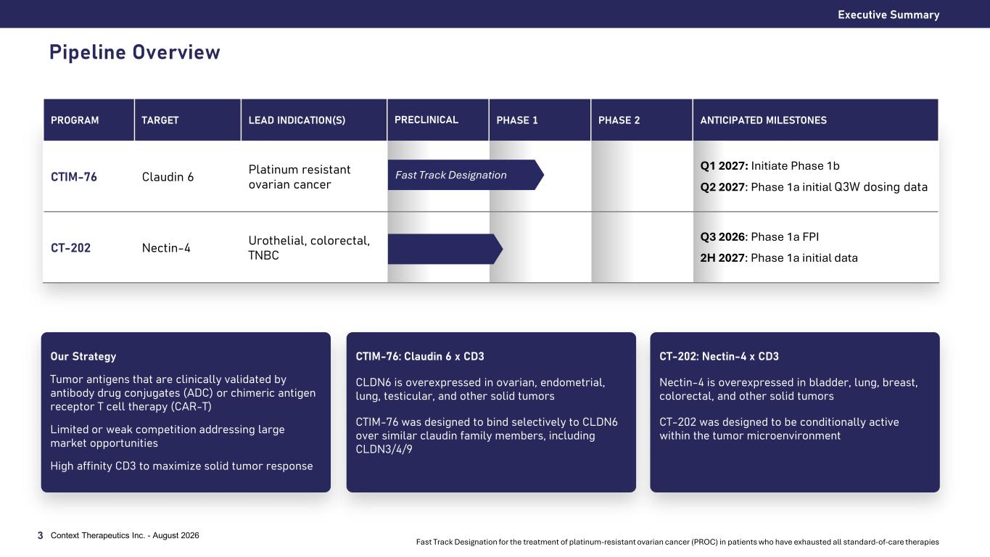
Executive Summary Pipeline Overview 3 PROGRAM TARGET LEAD INDICATION(S) PRECLINICAL PHASE 1 PHASE 2 ANTICIPATED MILESTONES CTIM-76 Claudin 6 Platinum resistant ovarian cancer Q1 2027: Initiate Phase 1b Q2 2027: Phase 1a initial Q3W dosing data CT-202 Nectin-4 Urothelial, colorectal, TNBC Q3 2026: Phase 1a FPI 2H 2027: Phase 1a initial data Fast Track Designation Context Therapeutics Inc. - August 2026 CTIM-76: Claudin 6 x CD3 CLDN6 is overexpressed in ovarian, endometrial, lung, testicular, and other solid tumors CTIM-76 was designed to bind selectively to CLDN6 over similar claudin family members, including CLDN3/4/9 CT-202: Nectin-4 x CD3 Nectin-4 is overexpressed in bladder, lung, breast, colorectal, and other solid tumors CT-202 was designed to be conditionally active within the tumor microenvironment Our Strategy Tumor antigens that are clinically validated by antibody drug conjugates (ADC) or chimeric antigen receptor T cell therapy (CAR-T) Limited or weak competition addressing large market opportunities High affinity CD3 to maximize solid tumor response Fast Track Designation for the treatment of platinum-resistant ovarian cancer (PROC) in patients who have exhausted all standard-of-care therapies

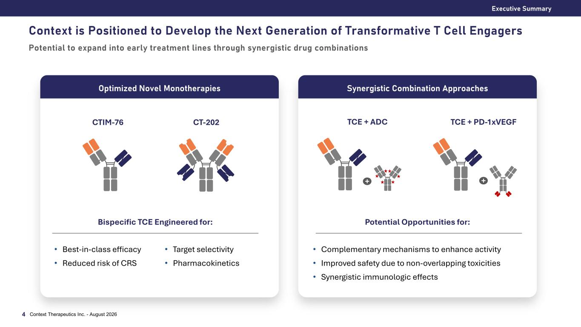
Context is Positioned to Develop the Next Generation of Transformative T Cell Engagers Potential to expand into early treatment lines through synergistic drug combinations Executive Summary Context Therapeutics Inc. - August 20264 Synergistic Combination ApproachesOptimized Novel Monotherapies CTIM-76 CT-202 Bispecific TCE Engineered for: Potential Opportunities for: • Best-in-class efficacy • Reduced risk of CRS • Target selectivity • Pharmacokinetics • Complementary mechanisms to enhance activity • Improved safety due to non-overlapping toxicities • Synergistic immunologic effects TCE + ADC TCE + PD-1xVEGF + +


T Cell Engager Strategy Context Therapeut ics Inc . - Augus t 20265

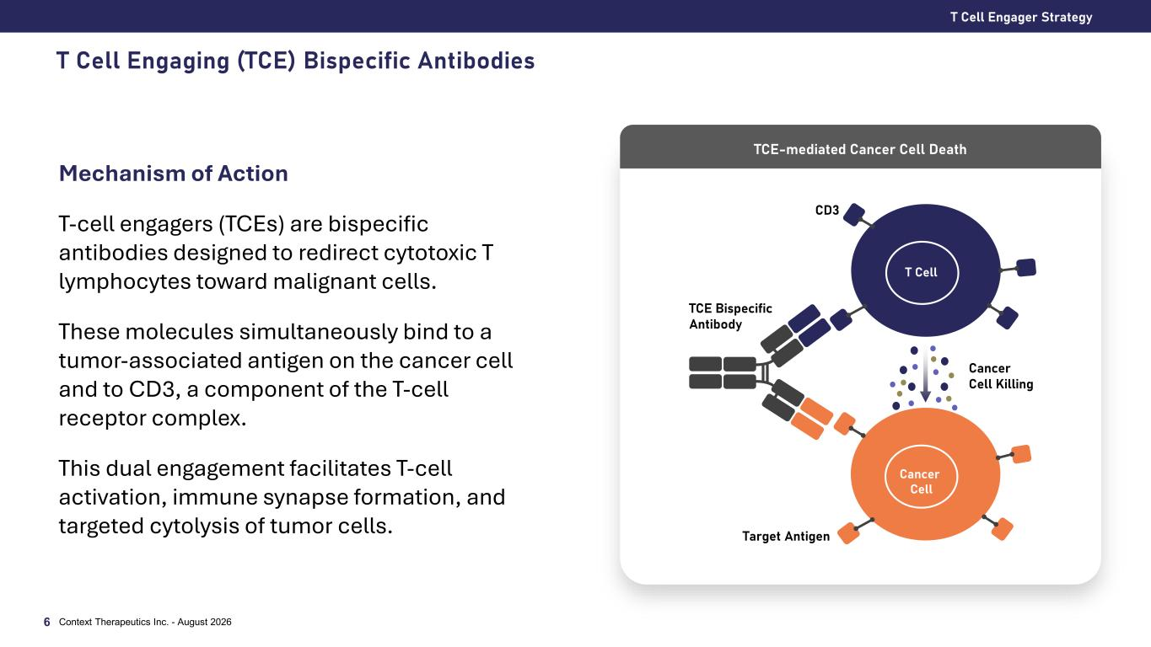
T Cell Engaging (TCE) Bispecific Antibodies T Cell Engager Strategy Context Therapeutics Inc. - August 20266 Mechanism of Action T-cell engagers (TCEs) are bispecific antibodies designed to redirect cytotoxic T lymphocytes toward malignant cells. These molecules simultaneously bind to a tumor-associated antigen on the cancer cell and to CD3, a component of the T-cell receptor complex. This dual engagement facilitates T-cell activation, immune synapse formation, and targeted cytolysis of tumor cells. TCE-mediated Cancer Cell Death TCE Bispecific Antibody T Cell Cancer Cell Target Antigen CD3 Cancer Cell Killing

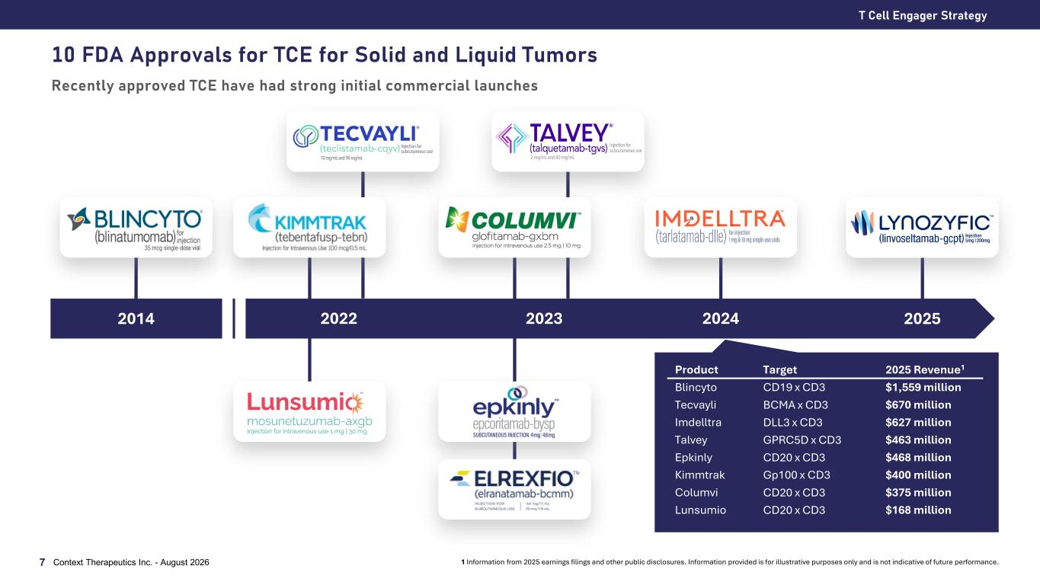
10 FDA Approvals for TCE for Solid and Liquid Tumors Recently approved TCE have had strong initial commercial launches T Cell Engager Strategy Context Therapeutics Inc. - August 20267 2024202320222014 2025 Product Target 2025 Revenue1 Blincyto CD19 x CD3 $1,559 million Tecvayli BCMA x CD3 $670 million Imdelltra DLL3 x CD3 $627 million Talvey GPRC5D x CD3 $463 million Epkinly CD20 x CD3 $468 million Kimmtrak Gp100 x CD3 $400 million Columvi CD20 x CD3 $375 million Lunsumio CD20 x CD3 $168 million 1 Information from 2025 earnings filings and other public disclosures. Information provided is for illustrative purposes only and is not indicative of future performance.

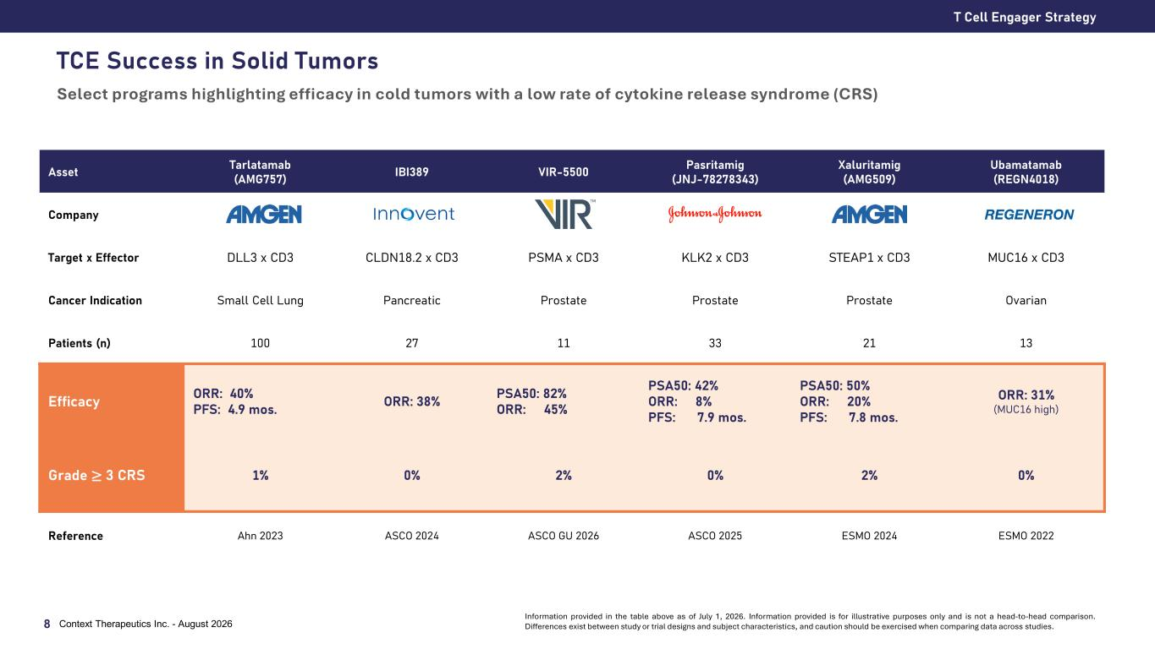
TCE Success in Solid Tumors Asset Tarlatamab (AMG757) IBI389 VIR-5500 Pasritamig (JNJ-78278343) Xaluritamig (AMG509) Ubamatamab (REGN4018) Company Target x Effector DLL3 x CD3 CLDN18.2 x CD3 PSMA x CD3 KLK2 x CD3 STEAP1 x CD3 MUC16 x CD3 Cancer Indication Small Cell Lung Pancreatic Prostate Prostate Prostate Ovarian Patients (n) 100 27 11 33 21 13 Efficacy ORR: 40% PFS: 4.9 mos. ORR: 38% PSA50: 82% ORR: 45% PSA50: 42% ORR: 8% PFS: 7.9 mos. PSA50: 50% ORR: 20% PFS: 7.8 mos. ORR: 31% (MUC16 high) Grade ≥ 3 CRS 1% 0% 2% 0% 2% 0% Reference Ahn 2023 ASCO 2024 ASCO GU 2026 ASCO 2025 ESMO 2024 ESMO 2022 T Cell Engager Strategy Context Therapeutics Inc. - August 20268 Information provided in the table above as of July 1, 2026. Information provided is for illustrative purposes only and is not a head-to-head comparison. Differences exist between study or trial designs and subject characteristics, and caution should be exercised when comparing data across studies. Select programs highlighting efficacy in cold tumors with a low rate of cytokine release syndrome (CRS)


CTIM-76 CLDN6 x CD3 bispecific antibody Context Therapeut ics Inc . - Augus t 20269

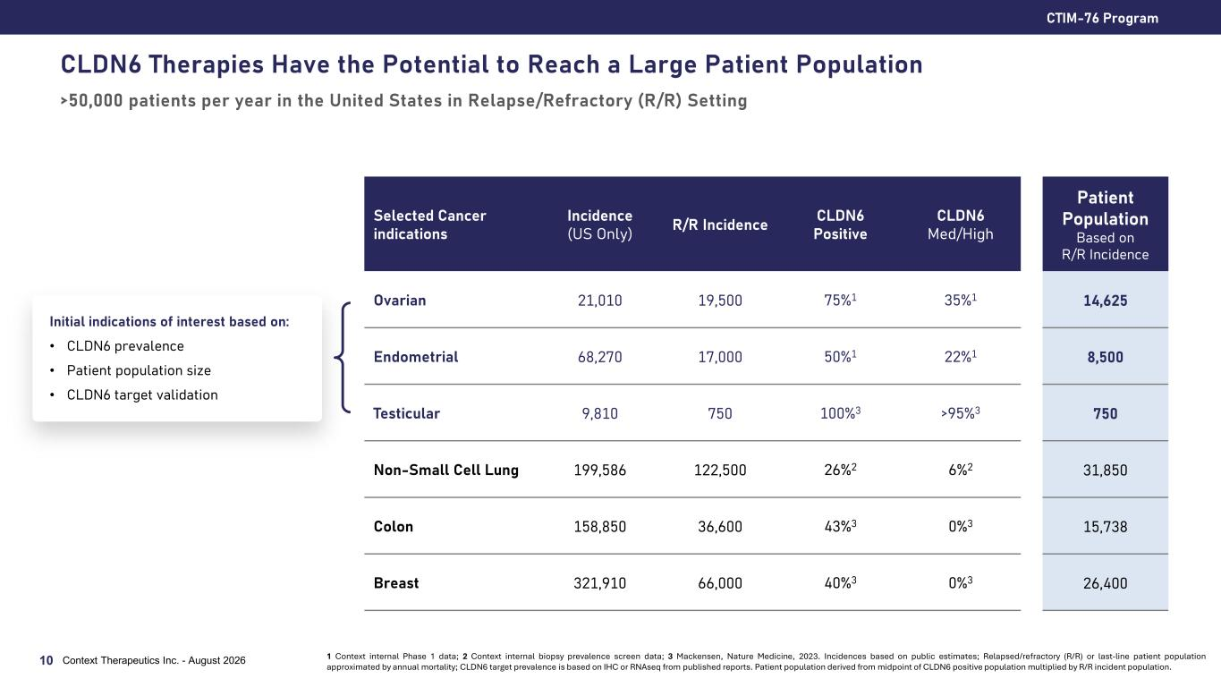
CLDN6 Therapies Have the Potential to Reach a Large Patient Population >50,000 patients per year in the United States in Relapse/Refractory (R/R) Setting CTIM-76 Program 10 Context Therapeutics Inc. - August 2026 Initial indications of interest based on: • CLDN6 prevalence • Patient population size • CLDN6 target validation Selected Cancer indications Incidence (US Only) R/R Incidence CLDN6 Positive CLDN6 Med/High Patient Population Based on R/R Incidence Ovarian 21,010 19,500 75%1 35%1 14,625 Endometrial 68,270 17,000 50%1 22%1 8,500 Testicular 9,810 750 100%3 >95%3 750 Non-Small Cell Lung 199,586 122,500 26%2 6%2 31,850 Colon 158,850 36,600 43%3 0%3 15,738 Breast 321,910 66,000 40%3 0%3 26,400 1 Context internal Phase 1 data; 2 Context internal biopsy prevalence screen data; 3 Mackensen, Nature Medicine, 2023. Incidences based on public estimates; Relapsed/refractory (R/R) or last-line patient population approximated by annual mortality; CLDN6 target prevalence is based on IHC or RNAseq from published reports. Patient population derived from midpoint of CLDN6 positive population multiplied by R/R incident population.

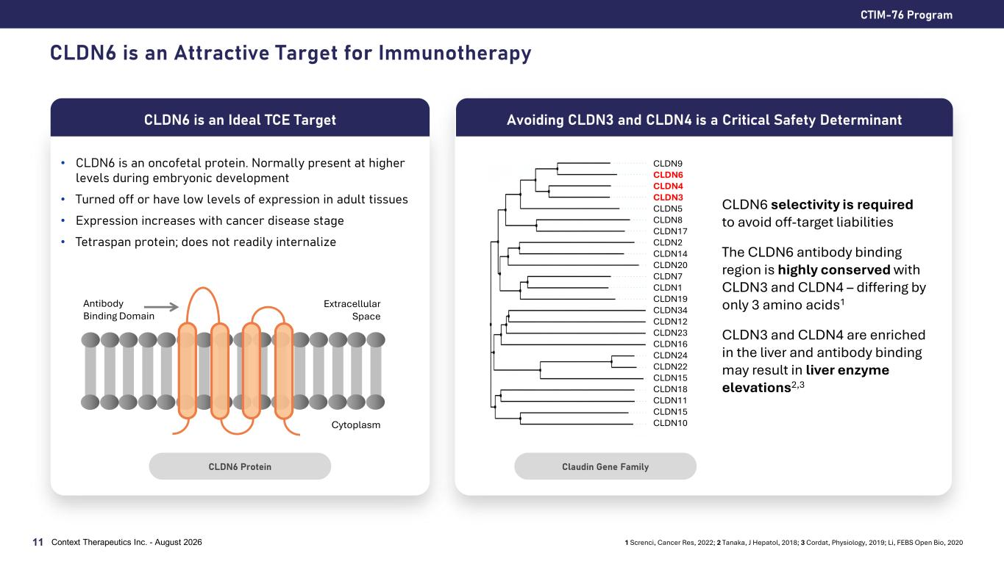
CLDN6 is an Attractive Target for Immunotherapy • CLDN6 is an oncofetal protein. Normally present at higher levels during embryonic development • Turned off or have low levels of expression in adult tissues • Expression increases with cancer disease stage • Tetraspan protein; does not readily internalize CTIM-76 Program Context Therapeutics Inc. - August 202611 CLDN6 is an Ideal TCE Target 1 Screnci, Cancer Res, 2022; 2 Tanaka, J Hepatol, 2018; 3 Cordat, Physiology, 2019; Li, FEBS Open Bio, 2020 CLDN6 selectivity is required to avoid off-target liabilities The CLDN6 antibody binding region is highly conserved with CLDN3 and CLDN4 – differing by only 3 amino acids1 CLDN3 and CLDN4 are enriched in the liver and antibody binding may result in liver enzyme elevations2,3 Avoiding CLDN3 and CLDN4 is a Critical Safety Determinant CLDN6 Protein Claudin Gene Family Extracellular Space Cytoplasm Antibody Binding Domain CLDN9 CLDN6 CLDN4 CLDN3 CLDN5 CLDN8 CLDN17 CLDN2 CLDN14 CLDN20 CLDN7 CLDN1 CLDN19 CLDN34 CLDN12 CLDN23 CLDN16 CLDN24 CLDN22 CLDN15 CLDN18 CLDN11 CLDN15 CLDN10

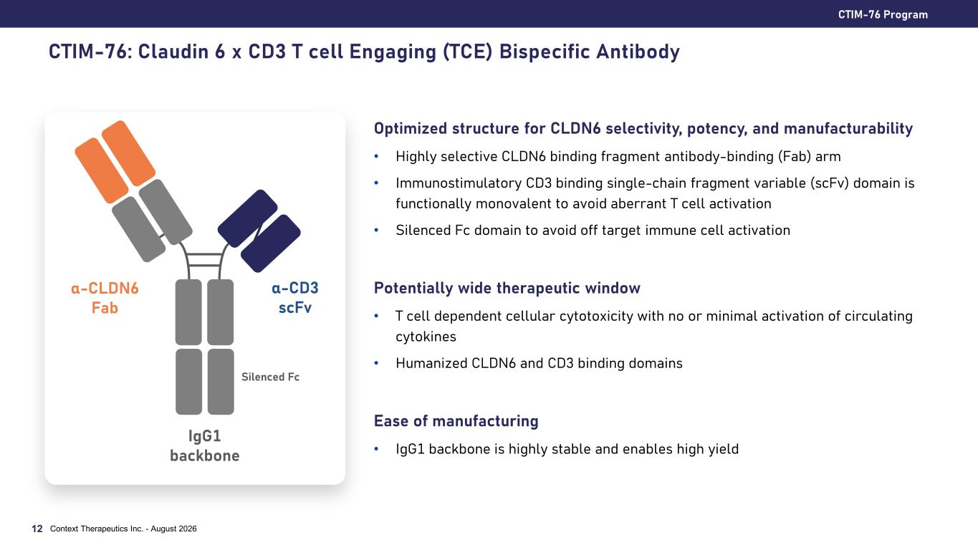
CTIM-76: Claudin 6 x CD3 T cell Engaging (TCE) Bispecific Antibody Optimized structure for CLDN6 selectivity, potency, and manufacturability • Highly selective CLDN6 binding fragment antibody-binding (Fab) arm • Immunostimulatory CD3 binding single-chain fragment variable (scFv) domain is functionally monovalent to avoid aberrant T cell activation • Silenced Fc domain to avoid off target immune cell activation Potentially wide therapeutic window • T cell dependent cellular cytotoxicity with no or minimal activation of circulating cytokines • Humanized CLDN6 and CD3 binding domains Ease of manufacturing • IgG1 backbone is highly stable and enables high yield CTIM-76 Program Context Therapeutics Inc. - August 202612 α-CLDN6 Fab α-CD3 scFv IgG1 backbone Silenced Fc

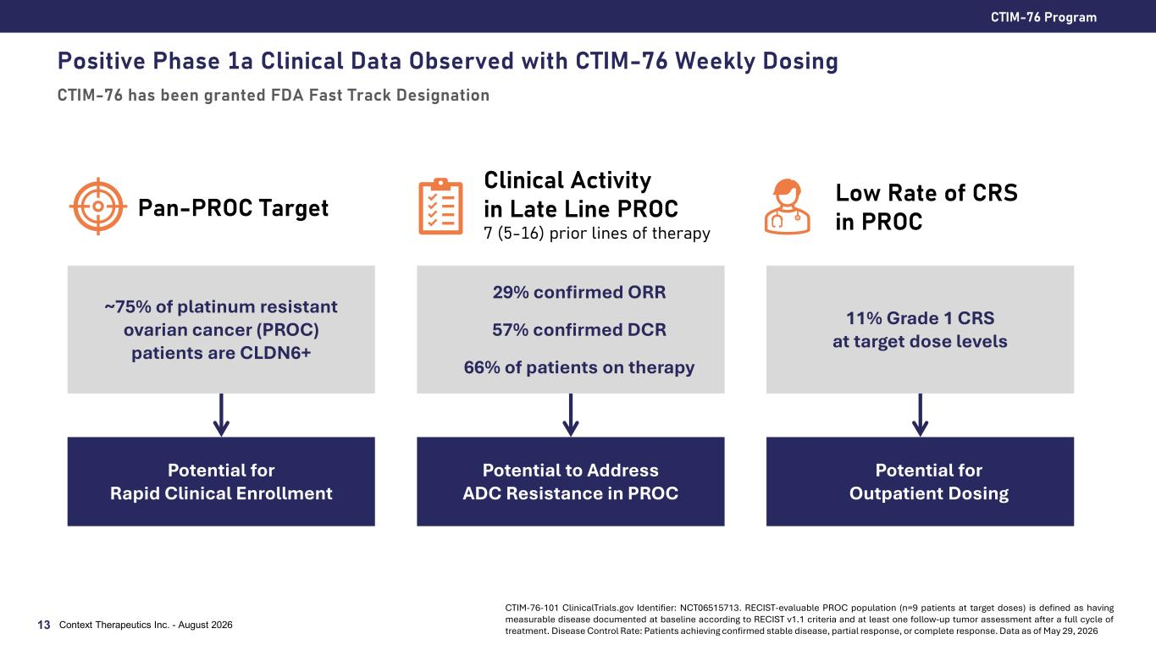
Positive Phase 1a Clinical Data Observed with CTIM-76 Weekly Dosing CTIM-76 has been granted FDA Fast Track Designation CTIM-76 Program Context Therapeutics Inc. - August 202613 Pan-PROC Target Clinical Activity in Late Line PROC 7 (5-16) prior lines of therapy Low Rate of CRS in PROC ~75% of platinum resistant ovarian cancer (PROC) patients are CLDN6+ Potential for Rapid Clinical Enrollment 29% confirmed ORR 57% confirmed DCR 66% of patients on therapy Potential to Address ADC Resistance in PROC 11% Grade 1 CRS at target dose levels Potential for Outpatient Dosing CTIM-76-101 ClinicalTrials.gov Identifier: NCT06515713. RECIST-evaluable PROC population (n=9 patients at target doses) is defined as having measurable disease documented at baseline according to RECIST v1.1 criteria and at least one follow-up tumor assessment after a full cycle of treatment. Disease Control Rate: Patients achieving confirmed stable disease, partial response, or complete response. Data as of May 29, 2026

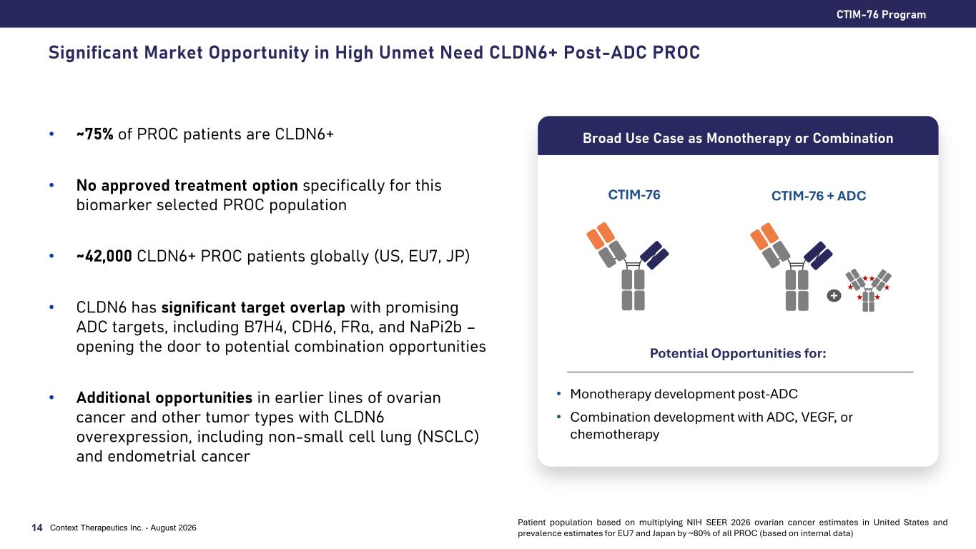
Significant Market Opportunity in High Unmet Need CLDN6+ Post-ADC PROC • ~75% of PROC patients are CLDN6+ • No approved treatment option specifically for this biomarker selected PROC population • ~42,000 CLDN6+ PROC patients globally (US, EU7, JP) • CLDN6 has significant target overlap with promising ADC targets, including B7H4, CDH6, FRα, and NaPi2b – opening the door to potential combination opportunities • Additional opportunities in earlier lines of ovarian cancer and other tumor types with CLDN6 overexpression, including non-small cell lung (NSCLC) and endometrial cancer CTIM-76 Program Context Therapeutics Inc. - August 202614 Broad Use Case as Monotherapy or Combination Potential Opportunities for: • Monotherapy development post-ADC • Combination development with ADC, VEGF, or chemotherapy CTIM-76 + ADC + CTIM-76 Patient population based on multiplying NIH SEER 2026 ovarian cancer estimates in United States and prevalence estimates for EU7 and Japan by ~80% of all PROC (based on internal data)

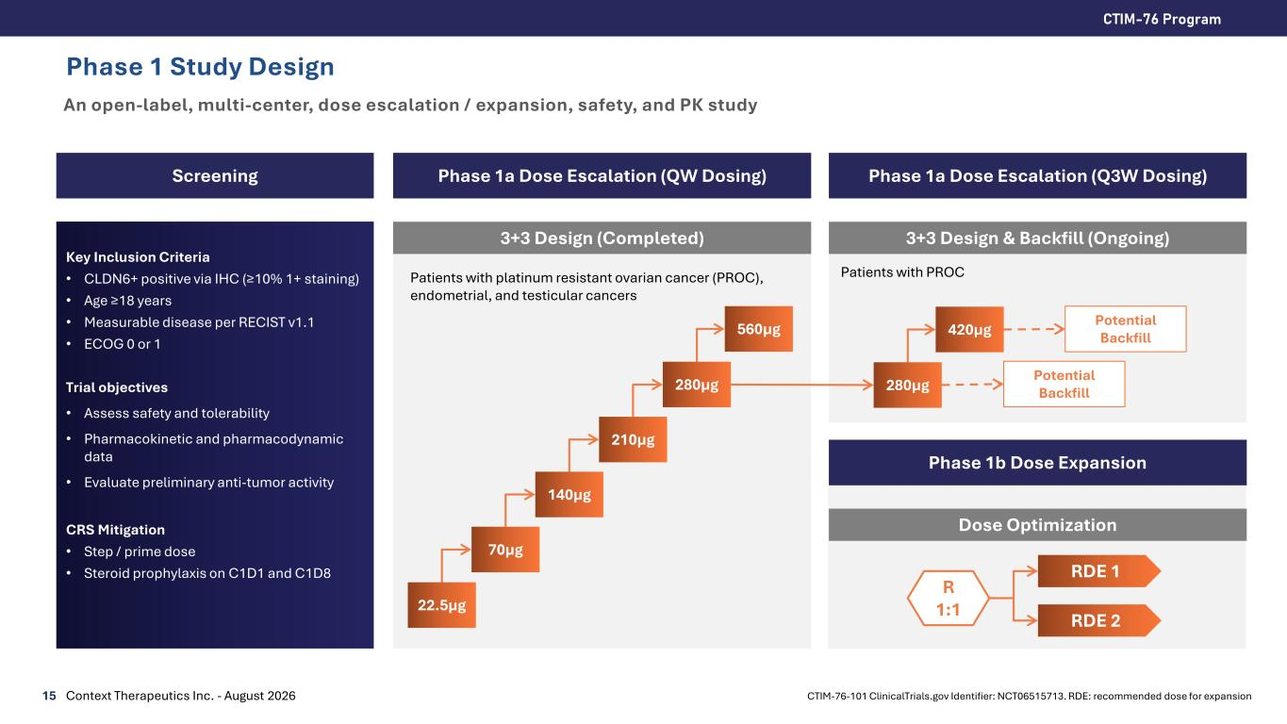
Phase 1 Study Design An open-label, multi-center, dose escalation / expansion, safety, and PK study 15 CTIM-76 Program Context Therapeutics Inc. - August 2026 Screening Phase 1a Dose Escalation (QW Dosing) Key Inclusion Criteria • CLDN6+ positive via IHC (≥10% 1+ staining) • Age ≥18 years • Measurable disease per RECIST v1.1 • ECOG 0 or 1 Trial objectives • Assess safety and tolerability • Pharmacokinetic and pharmacodynamic data • Evaluate preliminary anti-tumor activity CRS Mitigation • Step / prime dose • Steroid prophylaxis on C1D1 and C1D8 3+3 Design (Completed) Phase 1b Dose Expansion 22.5µg 70µg 140µg 210µg 280µg Dose Optimization R 1:1 RDE 1 RDE 2 560µg 280µg 420µg Phase 1a Dose Escalation (Q3W Dosing) 3+3 Design & Backfill (Ongoing) Potential Backfill Potential Backfill Patients with platinum resistant ovarian cancer (PROC), endometrial, and testicular cancers Patients with PROC CTIM-76-101 ClinicalTrials.gov Identifier: NCT06515713. RDE: recommended dose for expansion

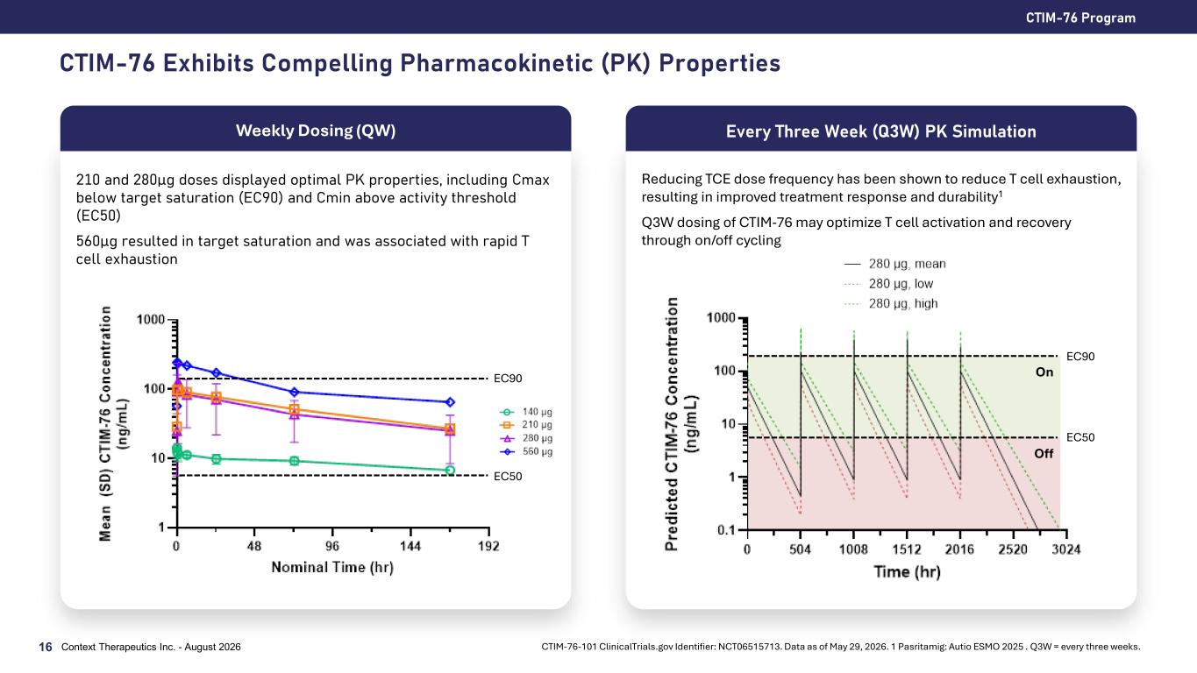
CTIM-76 Exhibits Compelling Pharmacokinetic (PK) Properties CTIM-76 Program Context Therapeutics Inc. - August 202616 CTIM-76-101 ClinicalTrials.gov Identifier: NCT06515713. Data as of May 29, 2026. 1 Pasritamig: Autio ESMO 2025 . Q3W = every three weeks. 210 and 280µg doses displayed optimal PK properties, including Cmax below target saturation (EC90) and Cmin above activity threshold (EC50) 560µg resulted in target saturation and was associated with rapid T cell exhaustion Weekly Dosing (QW) Reducing TCE dose frequency has been shown to reduce T cell exhaustion, resulting in improved treatment response and durability1 Q3W dosing of CTIM-76 may optimize T cell activation and recovery through on/off cycling Every Three Week (Q3W) PK Simulation On Off EC50 EC90 EC50 EC90

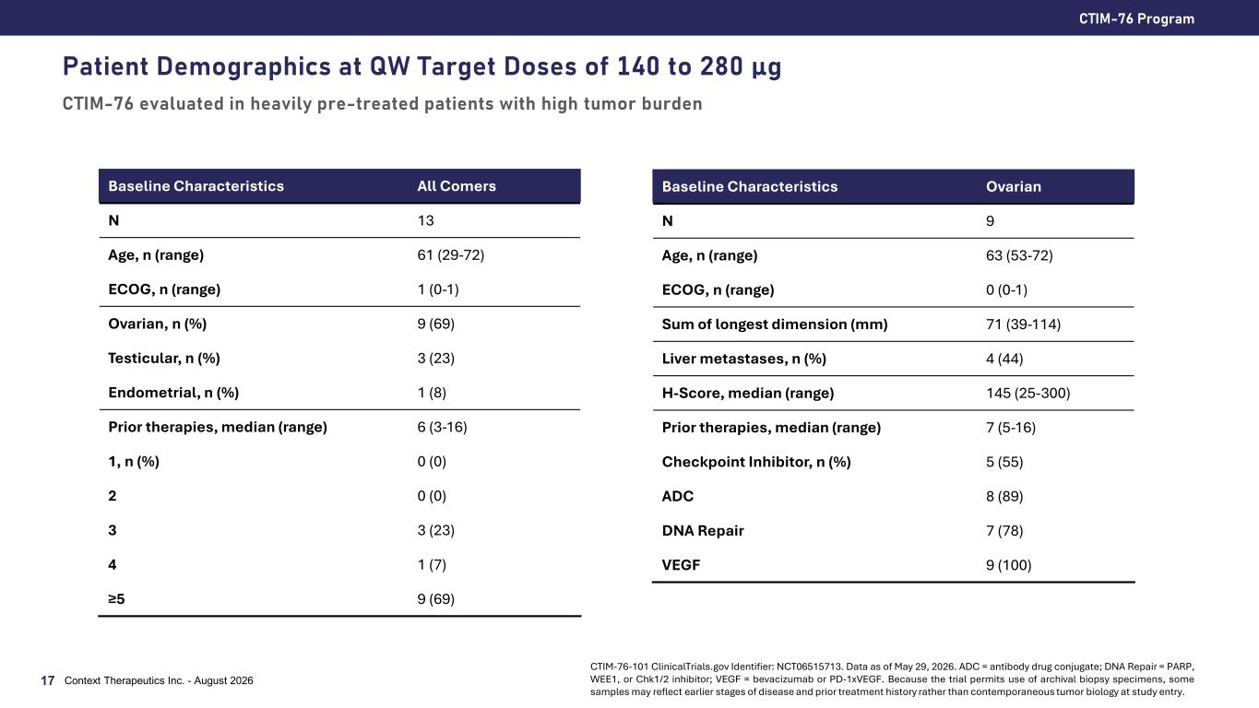
Patient Demographics at QW Target Doses of 140 to 280 µg CTIM-76 evaluated in heavily pre-treated patients with high tumor burden CTIM-76 Program Context Therapeutics Inc. - August 202617 Baseline Characteristics All Comers N 13 Age, n (range) 61 (29-72) ECOG, n (range) 1 (0-1) Ovarian, n (%) 9 (69) Testicular, n (%) 3 (23) Endometrial, n (%) 1 (8) Prior therapies, median (range) 6 (3-16) 1, n (%) 0 (0) 2 0 (0) 3 3 (23) 4 1 (7) ≥5 9 (69) Baseline Characteristics Ovarian N 9 Age, n (range) 63 (53-72) ECOG, n (range) 0 (0-1) Sum of longest dimension (mm) 71 (39-114) Liver metastases, n (%) 4 (44) H-Score, median (range) 145 (25-300) Prior therapies, median (range) 7 (5-16) Checkpoint Inhibitor, n (%) 5 (55) ADC 8 (89) DNA Repair 7 (78) VEGF 9 (100) CTIM-76-101 ClinicalTrials.gov Identifier: NCT06515713. Data as of May 29, 2026. ADC = antibody drug conjugate; DNA Repair = PARP, WEE1, or Chk1/2 inhibitor; VEGF = bevacizumab or PD-1xVEGF. Because the trial permits use of archival biopsy specimens, some samples may reflect earlier stages of disease and prior treatment history rather than contemporaneous tumor biology at study entry.

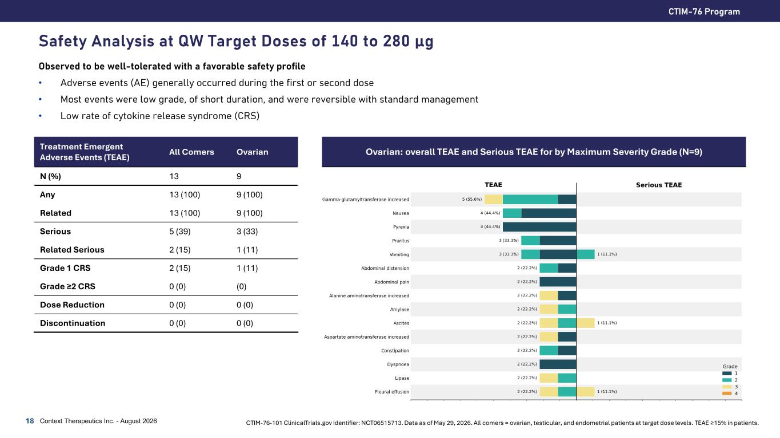
Safety Analysis at QW Target Doses of 140 to 280 µg Observed to be well-tolerated with a favorable safety profile • Adverse events (AE) generally occurred during the first or second dose • Most events were low grade, of short duration, and were reversible with standard management • Low rate of cytokine release syndrome (CRS) CTIM-76 Program Context Therapeutics Inc. - August 202618 CTIM-76-101 ClinicalTrials.gov Identifier: NCT06515713. Data as of May 29, 2026. All comers = ovarian, testicular, and endometrial patients at target dose levels. TEAE ≥15% in patients. Treatment Emergent Adverse Events (TEAE) All Comers Ovarian N (%) 13 9 Any 13 (100) 9 (100) Related 13 (100) 9 (100) Serious 5 (39) 3 (33) Related Serious 2 (15) 1 (11) Grade 1 CRS 2 (15) 1 (11) Grade ≥2 CRS 0 (0) (0) Dose Reduction 0 (0) 0 (0) Discontinuation 0 (0) 0 (0) Ovarian: overall TEAE and Serious TEAE for by Maximum Severity Grade (N=9)

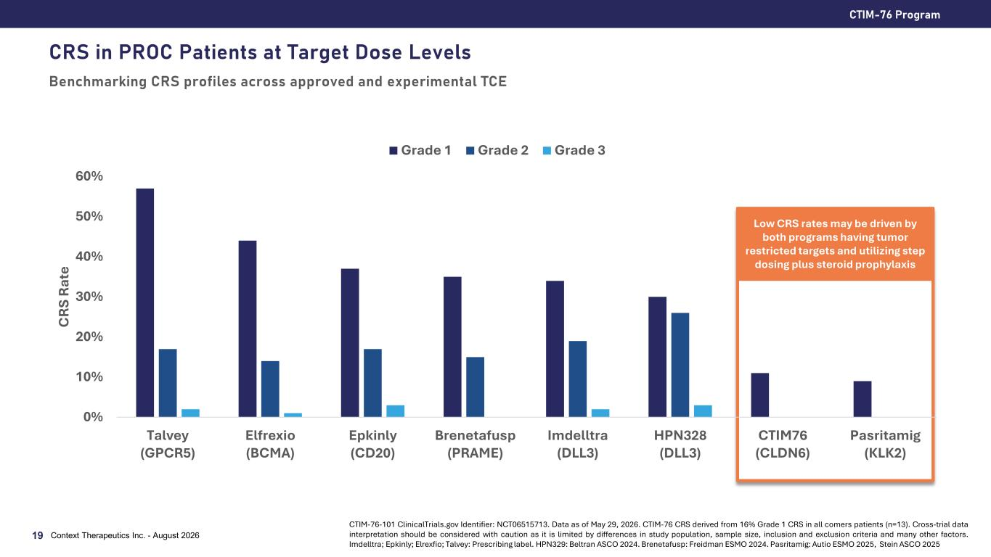
CRS in PROC Patients at Target Dose Levels Benchmarking CRS profiles across approved and experimental TCE 0% 10% 20% 30% 40% 50% 60% Talvey (GPCR5) Elfrexio (BCMA) Epkinly (CD20) Brenetafusp (PRAME) Imdelltra (DLL3) HPN328 (DLL3) CTIM76 (CLDN6) Pasritamig (KLK2) C RS R at e Grade 1 Grade 2 Grade 3 CTIM-76 Program Context Therapeutics Inc. - August 202619 CTIM-76-101 ClinicalTrials.gov Identifier: NCT06515713. Data as of May 29, 2026. CTIM-76 CRS derived from 16% Grade 1 CRS in all comers patients (n=13). Cross-trial data interpretation should be considered with caution as it is limited by differences in study population, sample size, inclusion and exclusion criteria and many other factors. Imdelltra; Epkinly; Elrexfio; Talvey: Prescribing label. HPN329: Beltran ASCO 2024. Brenetafusp: Freidman ESMO 2024. Pasritamig: Autio ESMO 2025, Stein ASCO 2025 Low CRS rates may be driven by both programs having tumor restricted targets and utilizing step dosing plus steroid prophylaxis

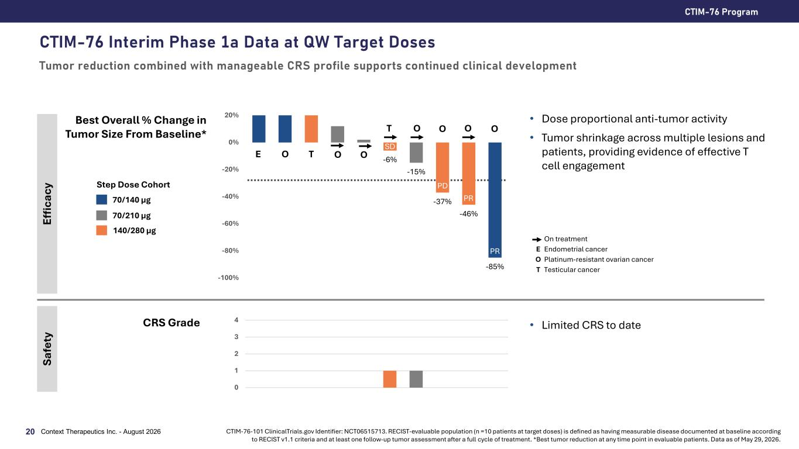
CTIM-76 Interim Phase 1a Data at QW Target Doses Tumor reduction combined with manageable CRS profile supports continued clinical development CTIM-76 Program Context Therapeutics Inc. - August 202620 Best Overall % Change in Tumor Size From Baseline* CRS Grade Ef fic ac y Sa fe ty -6% -15% -37% -46% -85% -100% -80% -60% -40% -20% 0% 20% Step Dose Cohort 70/140 µg 70/210 µg 0 1 2 3 4 • Limited CRS to date • Dose proportional anti-tumor activity • Tumor shrinkage across multiple lesions and patients, providing evidence of effective T cell engagement E O T T O O On treatment E Endometrial cancer O Platinum-resistant ovarian cancer T Testicular cancer PR PR PD SD O CTIM-76-101 ClinicalTrials.gov Identifier: NCT06515713. RECIST-evaluable population (n =10 patients at target doses) is defined as having measurable disease documented at baseline according to RECIST v1.1 criteria and at least one follow-up tumor assessment after a full cycle of treatment. *Best tumor reduction at any time point in evaluable patients. Data as of May 29, 2026. O 140/280 µg O O

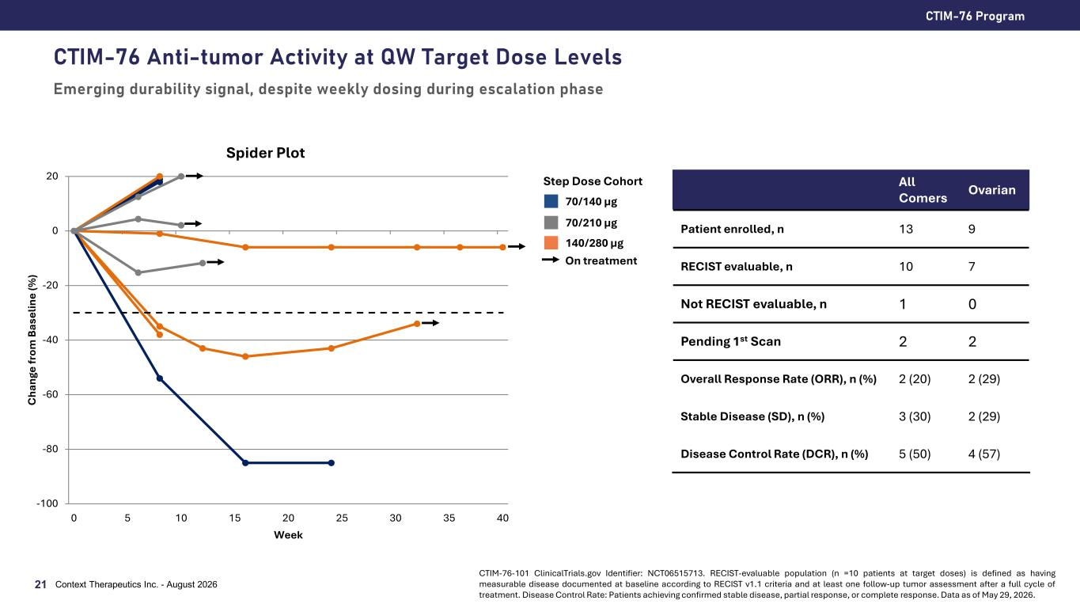
CTIM-76 Anti-tumor Activity at QW Target Dose Levels Emerging durability signal, despite weekly dosing during escalation phase CTIM-76 Program 21 CTIM-76-101 ClinicalTrials.gov Identifier: NCT06515713. RECIST-evaluable population (n =10 patients at target doses) is defined as having measurable disease documented at baseline according to RECIST v1.1 criteria and at least one follow-up tumor assessment after a full cycle of treatment. Disease Control Rate: Patients achieving confirmed stable disease, partial response, or complete response. Data as of May 29, 2026. All Comers Ovarian Patient enrolled, n 13 9 RECIST evaluable, n 10 7 Not RECIST evaluable, n 1 0 Pending 1st Scan 2 2 Overall Response Rate (ORR), n (%) 2 (20) 2 (29) Stable Disease (SD), n (%) 3 (30) 2 (29) Disease Control Rate (DCR), n (%) 5 (50) 4 (57) Context Therapeutics Inc. - August 2026 70/140 µg 70/210 µg 140/280 µg Step Dose Cohort -100 -80 -60 -40 -20 0 20 0 5 10 15 20 25 30 35 40 C ha ng e fr om B as el in e (% ) Week Spider Plot On treatment

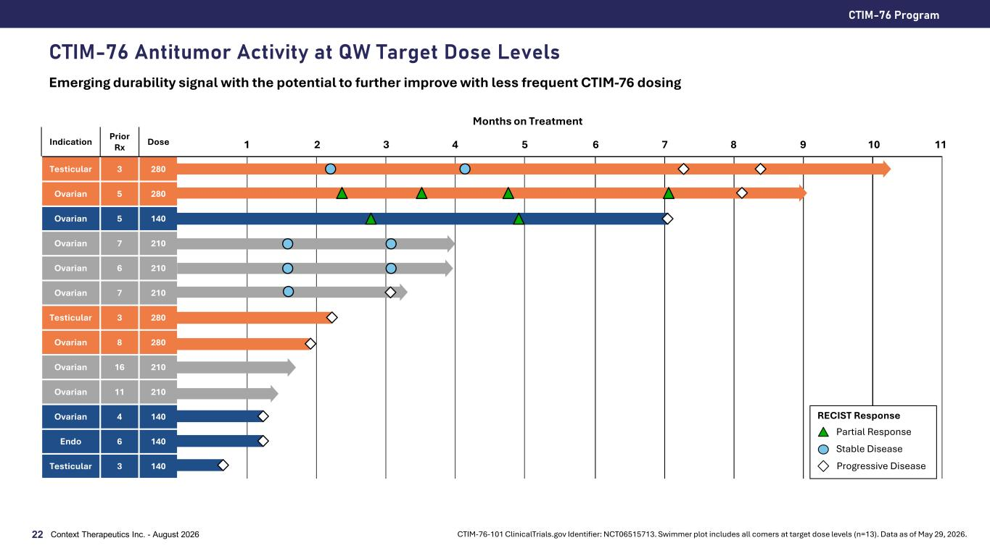
CTIM-76 Program Context Therapeutics Inc. - August 202622 CTIM-76 Antitumor Activity at QW Target Dose Levels Emerging durability signal with the potential to further improve with less frequent CTIM-76 dosing CTIM-76-101 ClinicalTrials.gov Identifier: NCT06515713. Swimmer plot includes all comers at target dose levels (n=13). Data as of May 29, 2026. Indication Prior Rx Dose Testicular 3 280 Ovarian 5 280 Ovarian 5 140 Ovarian 7 210 Ovarian 6 210 Ovarian 7 210 Testicular 3 280 Ovarian 8 280 Ovarian 16 210 Ovarian 11 210 Ovarian 4 140 Endo 6 140 Testicular 3 140 1 2 3 4 5 6 Months on Treatment 7 8 9 10 Progressive Disease Stable Disease Partial Response RECIST Response 11

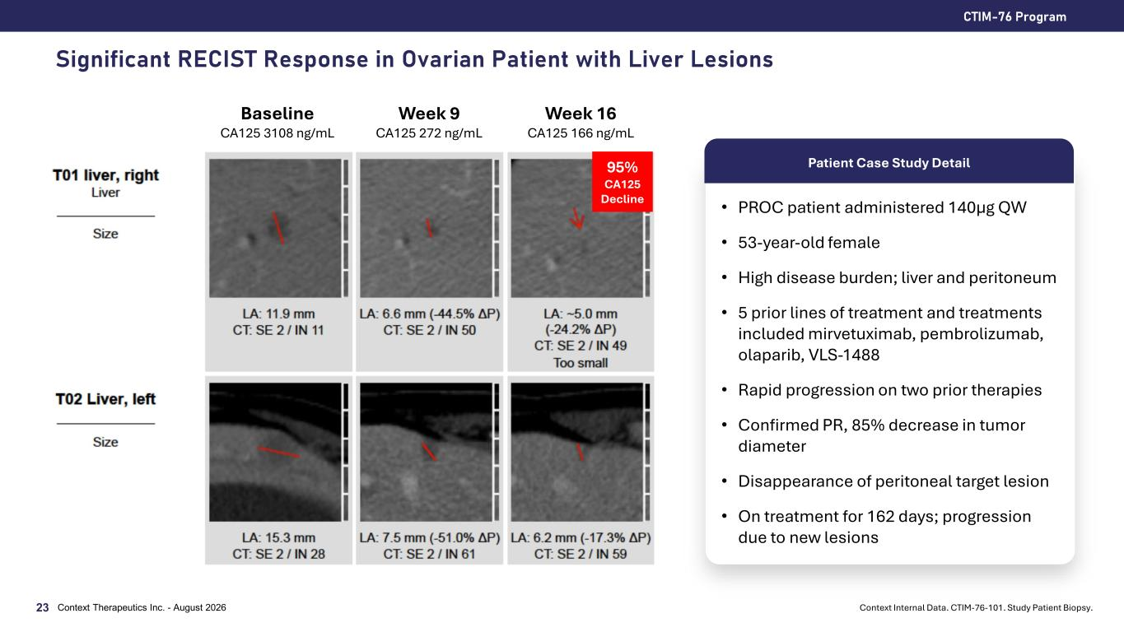
Significant RECIST Response in Ovarian Patient with Liver Lesions CTIM-76 Program Context Therapeutics Inc. - August 202623 Baseline CA125 3108 ng/mL Week 9 CA125 272 ng/mL Week 16 CA125 166 ng/mL • PROC patient administered 140µg QW • 53-year-old female • High disease burden; liver and peritoneum • 5 prior lines of treatment and treatments included mirvetuximab, pembrolizumab, olaparib, VLS-1488 • Rapid progression on two prior therapies • Confirmed PR, 85% decrease in tumor diameter • Disappearance of peritoneal target lesion • On treatment for 162 days; progression due to new lesions 95% CA125 Decline Patient Case Study Detail Context Internal Data. CTIM-76-101. Study Patient Biopsy.

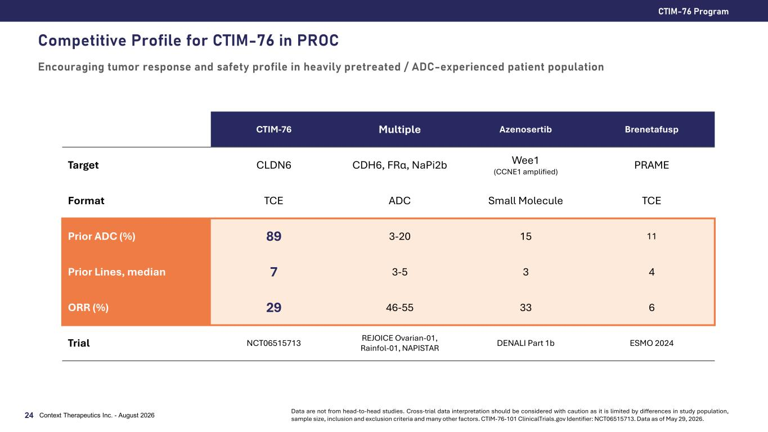
CTIM-76 Program Context Therapeutics Inc. - August 202624 Competitive Profile for CTIM-76 in PROC Encouraging tumor response and safety profile in heavily pretreated / ADC-experienced patient population CTIM-76 Multiple Azenosertib Brenetafusp Target CLDN6 CDH6, FRα, NaPi2b Wee1 (CCNE1 amplified) PRAME Format TCE ADC Small Molecule TCE Prior ADC (%) 89 3-20 15 11 Prior Lines, median 7 3-5 3 4 ORR (%) 29 46-55 33 6 Trial NCT06515713 REJOICE Ovarian-01, Rainfol-01, NAPISTAR DENALI Part 1b ESMO 2024 Data are not from head-to-head studies. Cross-trial data interpretation should be considered with caution as it is limited by differences in study population, sample size, inclusion and exclusion criteria and many other factors. CTIM-76-101 ClinicalTrials.gov Identifier: NCT06515713. Data as of May 29, 2026.

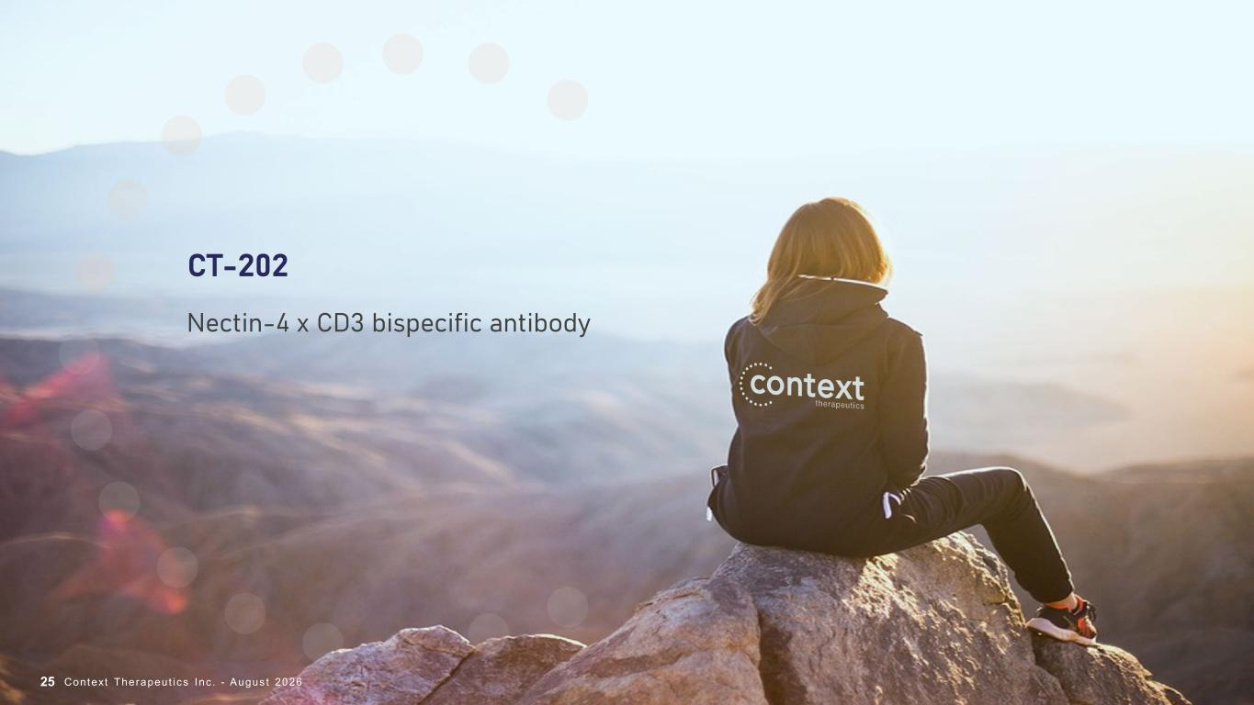
CT-202 Nectin-4 x CD3 bispecific antibody Context Therapeut ics Inc . - Augus t 202625

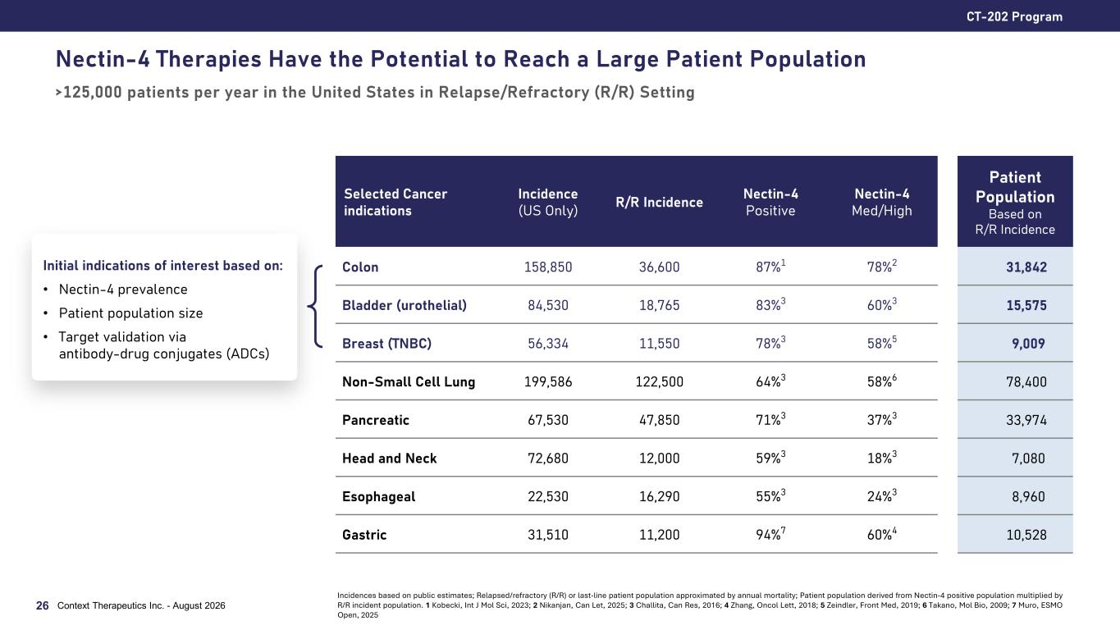
Nectin-4 Therapies Have the Potential to Reach a Large Patient Population >125,000 patients per year in the United States in Relapse/Refractory (R/R) Setting CT-202 Program 26 Context Therapeutics Inc. - August 2026 Selected Cancer indications Incidence (US Only) R/R Incidence Nectin-4 Positive Nectin-4 Med/High Patient Population Based on R/R Incidence Colon 158,850 36,600 87%1 78%2 31,842 Bladder (urothelial) 84,530 18,765 83%3 60%3 15,575 Breast (TNBC) 56,334 11,550 78%3 58%5 9,009 Non-Small Cell Lung 199,586 122,500 64%3 58%6 78,400 Pancreatic 67,530 47,850 71%3 37%3 33,974 Head and Neck 72,680 12,000 59%3 18%3 7,080 Esophageal 22,530 16,290 55%3 24%3 8,960 Gastric 31,510 11,200 94%7 60%4 10,528 Initial indications of interest based on: • Nectin-4 prevalence • Patient population size • Target validation via antibody-drug conjugates (ADCs) Incidences based on public estimates; Relapsed/refractory (R/R) or last-line patient population approximated by annual mortality; Patient population derived from Nectin-4 positive population multiplied by R/R incident population. 1 Kobecki, Int J Mol Sci, 2023; 2 Nikanjan, Can Let, 2025; 3 Challita, Can Res, 2016; 4 Zhang, Oncol Lett, 2018; 5 Zeindler, Front Med, 2019; 6 Takano, Mol Bio, 2009; 7 Muro, ESMO Open, 2025

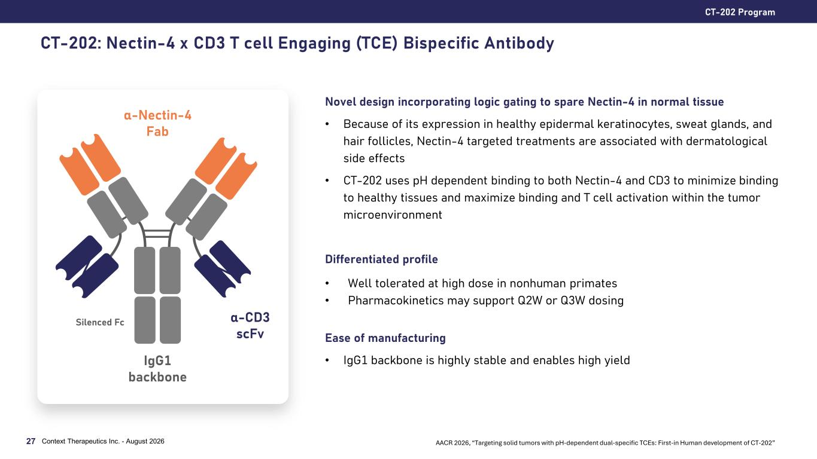
CT-202: Nectin-4 x CD3 T cell Engaging (TCE) Bispecific Antibody CT-202 Program Context Therapeutics Inc. - August 202627 α-Nectin-4 Fab α-CD3 scFv IgG1 backbone Silenced Fc Novel design incorporating logic gating to spare Nectin-4 in normal tissue • Because of its expression in healthy epidermal keratinocytes, sweat glands, and hair follicles, Nectin-4 targeted treatments are associated with dermatological side effects • CT-202 uses pH dependent binding to both Nectin-4 and CD3 to minimize binding to healthy tissues and maximize binding and T cell activation within the tumor microenvironment Differentiated profile • Well tolerated at high dose in nonhuman primates • Pharmacokinetics may support Q2W or Q3W dosing Ease of manufacturing • IgG1 backbone is highly stable and enables high yield AACR 2026, “Targeting solid tumors with pH-dependent dual-specific TCEs: First-in Human development of CT-202”

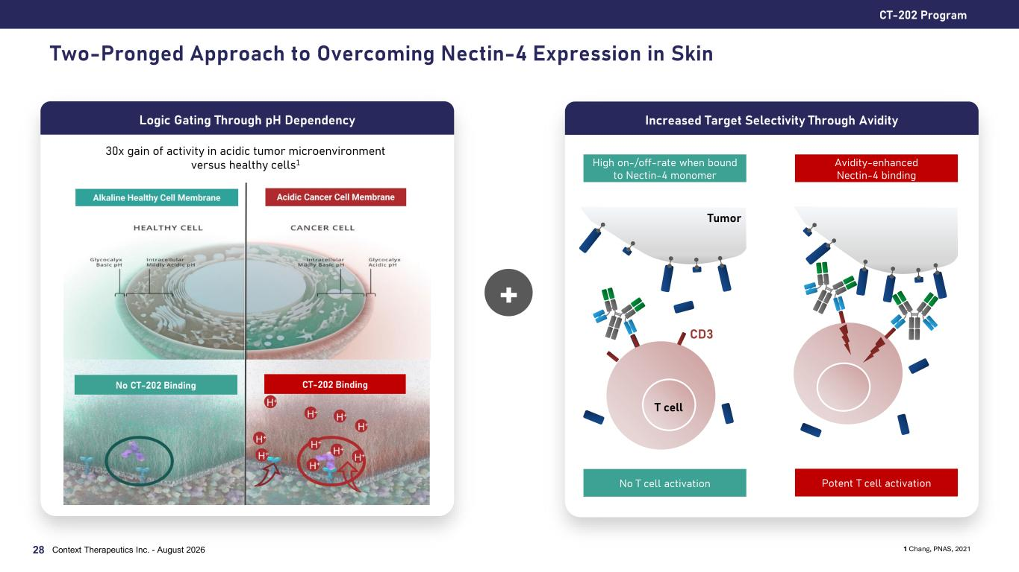
Two-Pronged Approach to Overcoming Nectin-4 Expression in Skin CT-202 Program 28 Logic Gating Through pH Dependency + Increased Target Selectivity Through Avidity 1 Chang, PNAS, 2021 CD3 Potent T cell activationNo T cell activation High on-/off-rate when bound to Nectin-4 monomer Avidity-enhanced Nectin-4 binding T cell Tumor 30x gain of activity in acidic tumor microenvironment versus healthy cells1 Context Therapeutics Inc. - August 2026 No CT-202 Binding CT-202 Binding

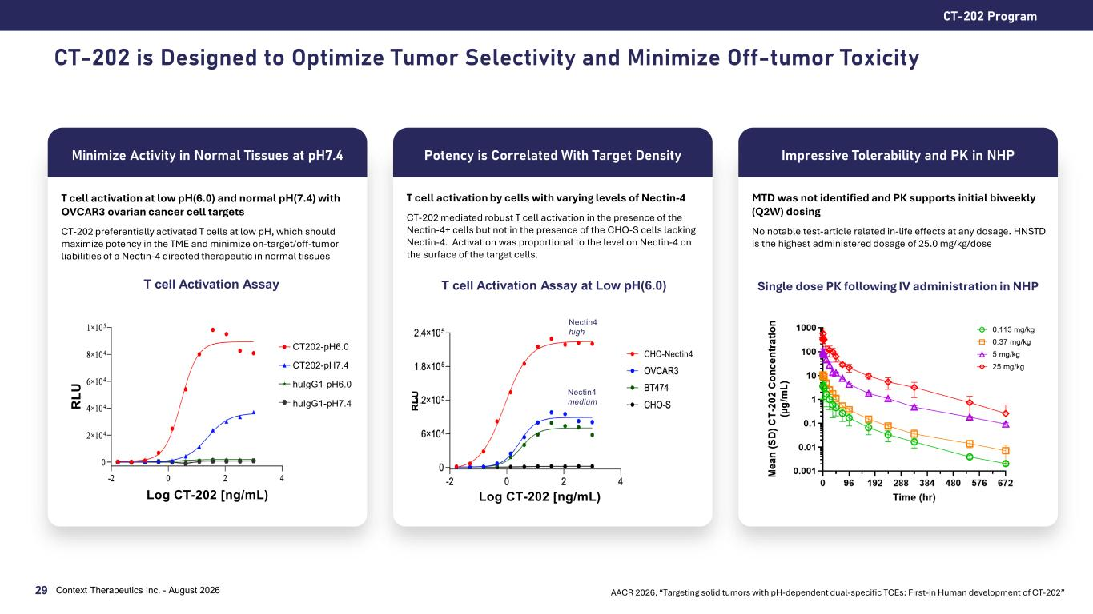
CT-202 is Designed to Optimize Tumor Selectivity and Minimize Off-tumor Toxicity CT-202 Program Context Therapeutics Inc. - August 202629 AACR 2026, “Targeting solid tumors with pH-dependent dual-specific TCEs: First-in Human development of CT-202” Minimize Activity in Normal Tissues at pH7.4 T cell activation at low pH(6.0) and normal pH(7.4) with OVCAR3 ovarian cancer cell targets CT-202 preferentially activated T cells at low pH, which should maximize potency in the TME and minimize on-target/off-tumor liabilities of a Nectin-4 directed therapeutic in normal tissues T cell Activation Assay CT202-pH6.0 CT202-pH7.4 huIgG1-pH6.0 huIgG1-pH7.4 Log CT-202 [ng/mL) R LU Potency is Correlated With Target Density T cell activation by cells with varying levels of Nectin-4 CT-202 mediated robust T cell activation in the presence of the Nectin-4+ cells but not in the presence of the CHO-S cells lacking Nectin-4. Activation was proportional to the level on Nectin-4 on the surface of the target cells. T cell Activation Assay at Low pH(6.0) Log CT-202 [ng/mL) Nectin4 high Nectin4 medium Impressive Tolerability and PK in NHP MTD was not identified and PK supports initial biweekly (Q2W) dosing No notable test-article related in-life effects at any dosage. HNSTD is the highest administered dosage of 25.0 mg/kg/dose Single dose PK following IV administration in NHP

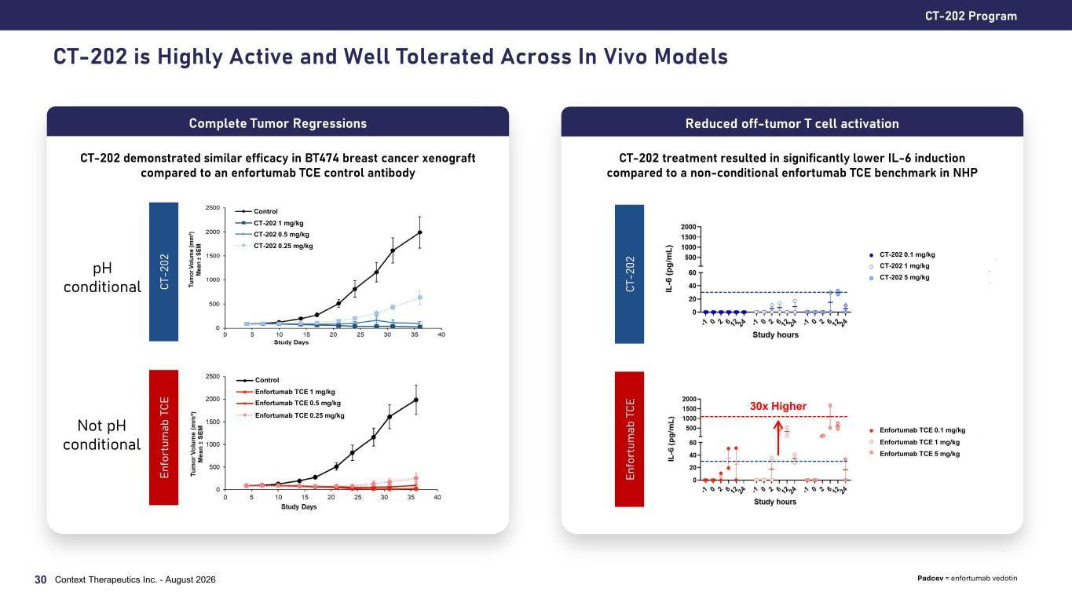
CT-202 is Highly Active and Well Tolerated Across In Vivo Models CT-202 Program Context Therapeutics Inc. - August 202630 Complete Tumor Regressions CT-202 demonstrated similar efficacy in BT474 breast cancer xenograft compared to an enfortumab TCE control antibody Reduced off-tumor T cell activation CT-202 treatment resulted in significantly lower IL-6 induction compared to a non-conditional enfortumab TCE benchmark in NHP CT -2 02 En fo rt um ab T CE CT -2 02 En fo rt um ab T CE Control CT-202 1 mg/kg CT-202 0.5 mg/kg CT-202 0.25 mg/kg Control Enfortumab TCE 1 mg/kg Enfortumab TCE 0.5 mg/kg Enfortumab TCE 0.25 mg/kg CT-202 0.1 mg/kg CT-202 1 mg/kg CT-202 5 mg/kg Enfortumab TCE 0.1 mg/kg Enfortumab TCE 1 mg/kg Enfortumab TCE 5 mg/kg Padcev = enfortumab vedotin 30x Higher pH conditional Not pH conditional

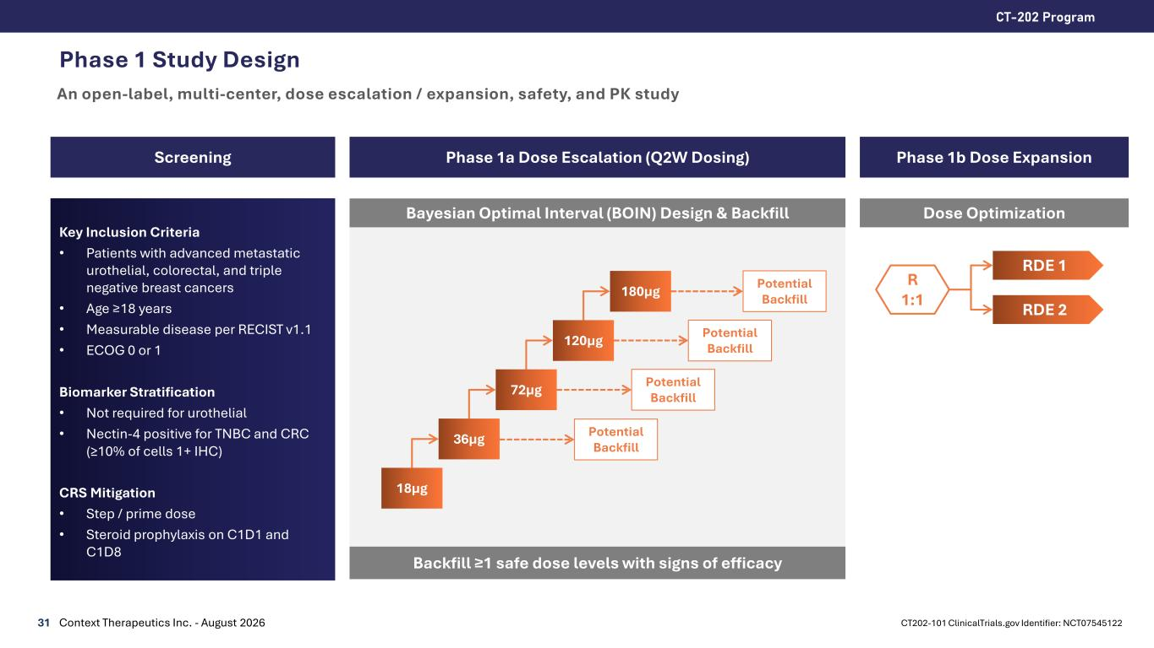
Phase 1 Study Design An open-label, multi-center, dose escalation / expansion, safety, and PK study 31 CT-202 Program Context Therapeutics Inc. - August 2026 Screening Phase 1a Dose Escalation (Q2W Dosing) Key Inclusion Criteria • Patients with advanced metastatic urothelial, colorectal, and triple negative breast cancers • Age ≥18 years • Measurable disease per RECIST v1.1 • ECOG 0 or 1 Biomarker Stratification • Not required for urothelial • Nectin-4 positive for TNBC and CRC (≥10% of cells 1+ IHC) CRS Mitigation • Step / prime dose • Steroid prophylaxis on C1D1 and C1D8 Bayesian Optimal Interval (BOIN) Design & Backfill Phase 1b Dose Expansion 18µg 36µg 72µg 120µg 180µg Backfill ≥1 safe dose levels with signs of efficacy Dose Optimization R 1:1 RDE 1 RDE 2 Potential Backfill Potential Backfill Potential Backfill CT202-101 ClinicalTrials.gov Identifier: NCT07545122 Potential Backfill

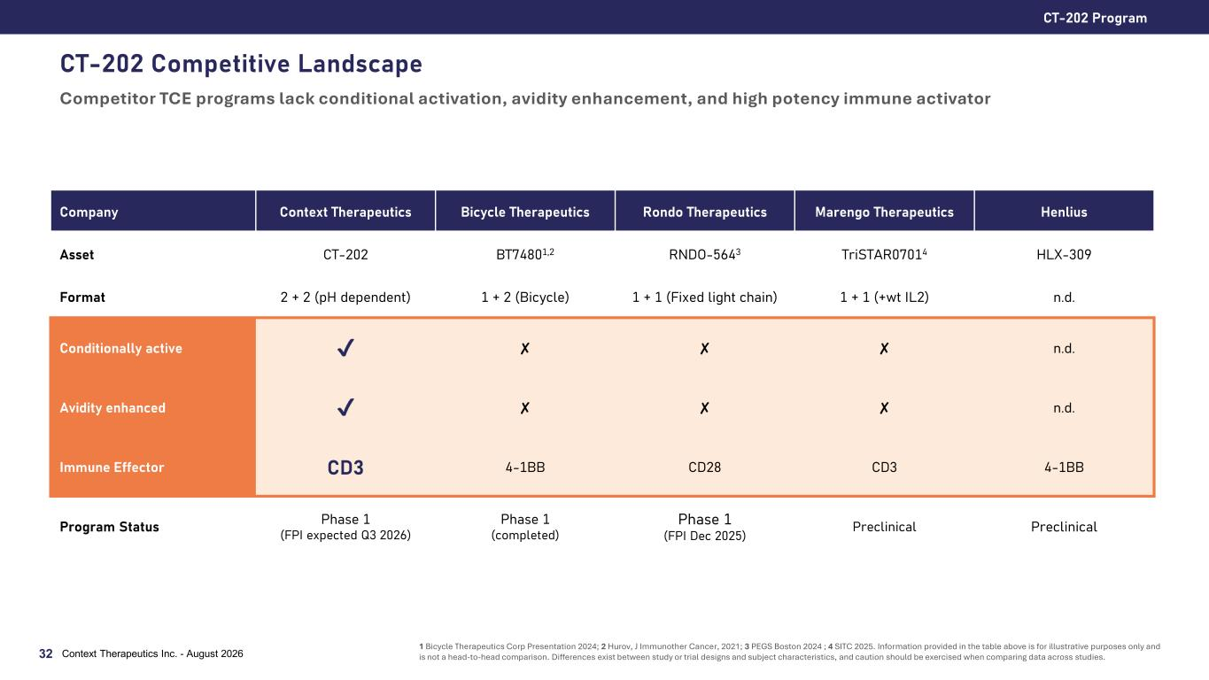
CT-202 Competitive Landscape Competitor TCE programs lack conditional activation, avidity enhancement, and high potency immune activator CT-202 Program Context Therapeutics Inc. - August 202632 Company Context Therapeutics Bicycle Therapeutics Rondo Therapeutics Marengo Therapeutics Henlius Asset CT-202 BT74801,2 RNDO-5643 TriSTAR07014 HLX-309 Format 2 + 2 (pH dependent) 1 + 2 (Bicycle) 1 + 1 (Fixed light chain) 1 + 1 (+wt IL2) n.d. Conditionally active ✘ ✘ ✘ n.d. Avidity enhanced ✘ ✘ ✘ n.d. Immune Effector CD3 4-1BB CD28 CD3 4-1BB Program Status Phase 1 (FPI expected Q3 2026) Phase 1 (completed) Phase 1 (FPI Dec 2025) Preclinical Preclinical 1 Bicycle Therapeutics Corp Presentation 2024; 2 Hurov, J Immunother Cancer, 2021; 3 PEGS Boston 2024 ; 4 SITC 2025. Information provided in the table above is for illustrative purposes only and is not a head-to-head comparison. Differences exist between study or trial designs and subject characteristics, and caution should be exercised when comparing data across studies.


Corporate 33 Context Therapeut ics Inc . - Augus t 2026

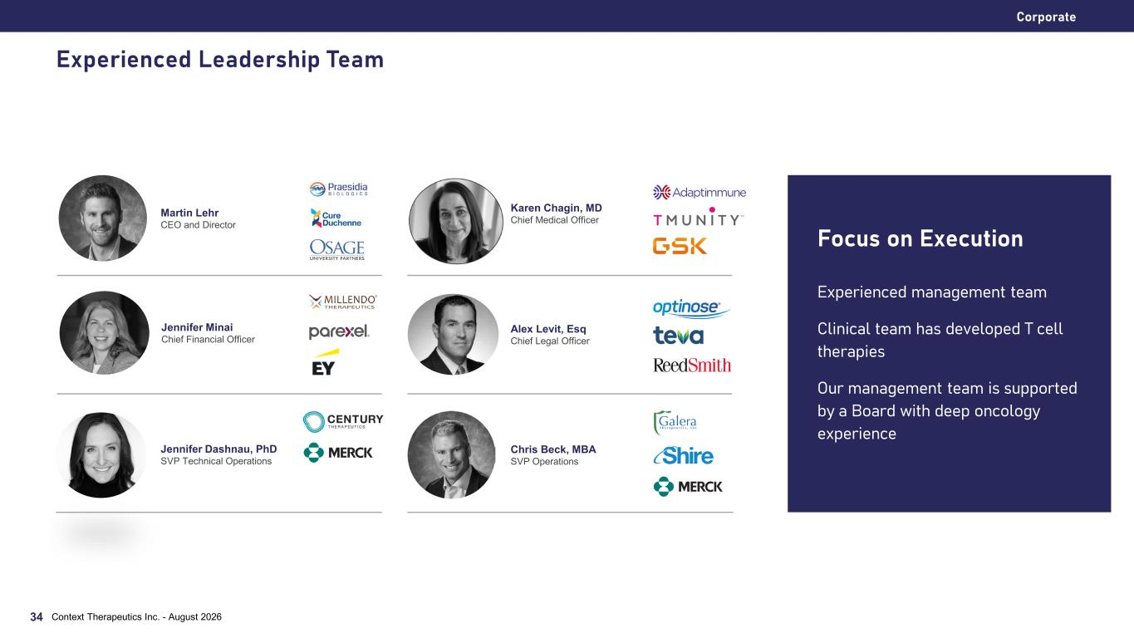
Corporate Experienced management team Clinical team has developed T cell therapies Our management team is supported by a Board with deep oncology experience Focus on Execution Martin Lehr CEO and Director Alex Levit, Esq Chief Legal Officer Karen Chagin, MD Chief Medical Officer Context Therapeutics Inc. - August 202634 Jennifer Dashnau, PhD SVP Technical Operations Jennifer Minai Chief Financial Officer Chris Beck, MBA SVP Operations Experienced Leadership Team

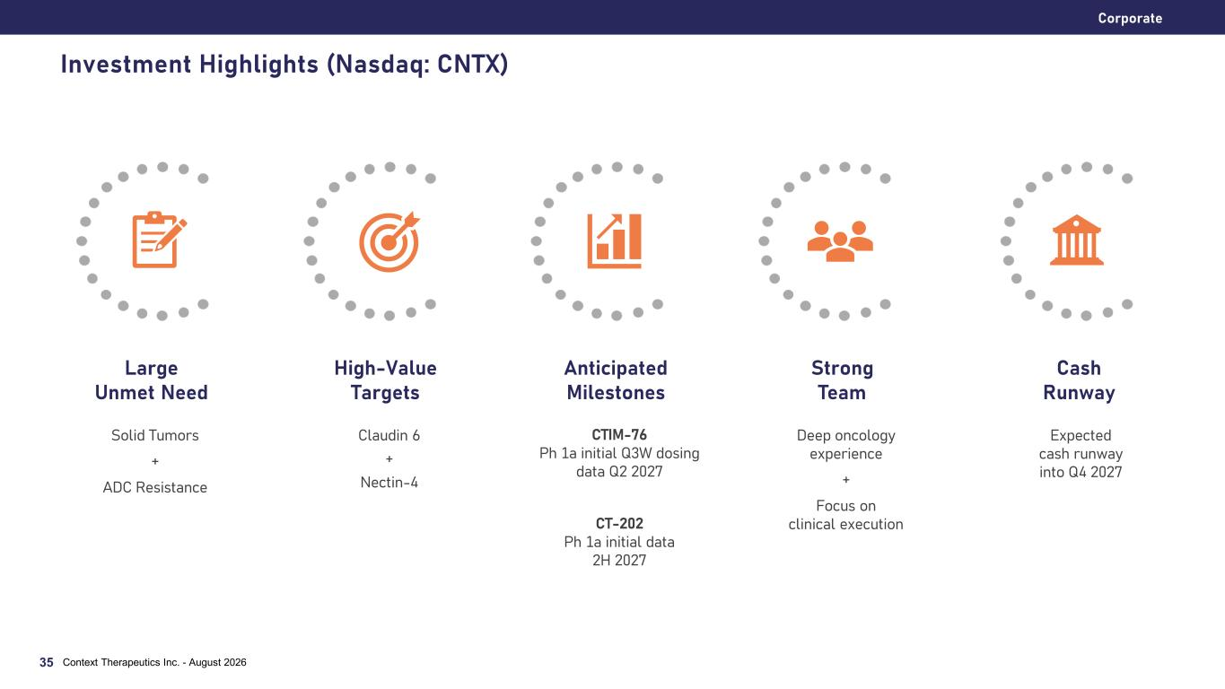
Corporate Investment Highlights (Nasdaq: CNTX) Solid Tumors + ADC Resistance Large Unmet Need Claudin 6 + Nectin-4 High-Value Targets CTIM-76 Ph 1a initial Q3W dosing data Q2 2027 CT-202 Ph 1a initial data 2H 2027 Anticipated Milestones Deep oncology experience + Focus on clinical execution Strong Team Expected cash runway into Q4 2027 Cash Runway Context Therapeutics Inc. - August 202635

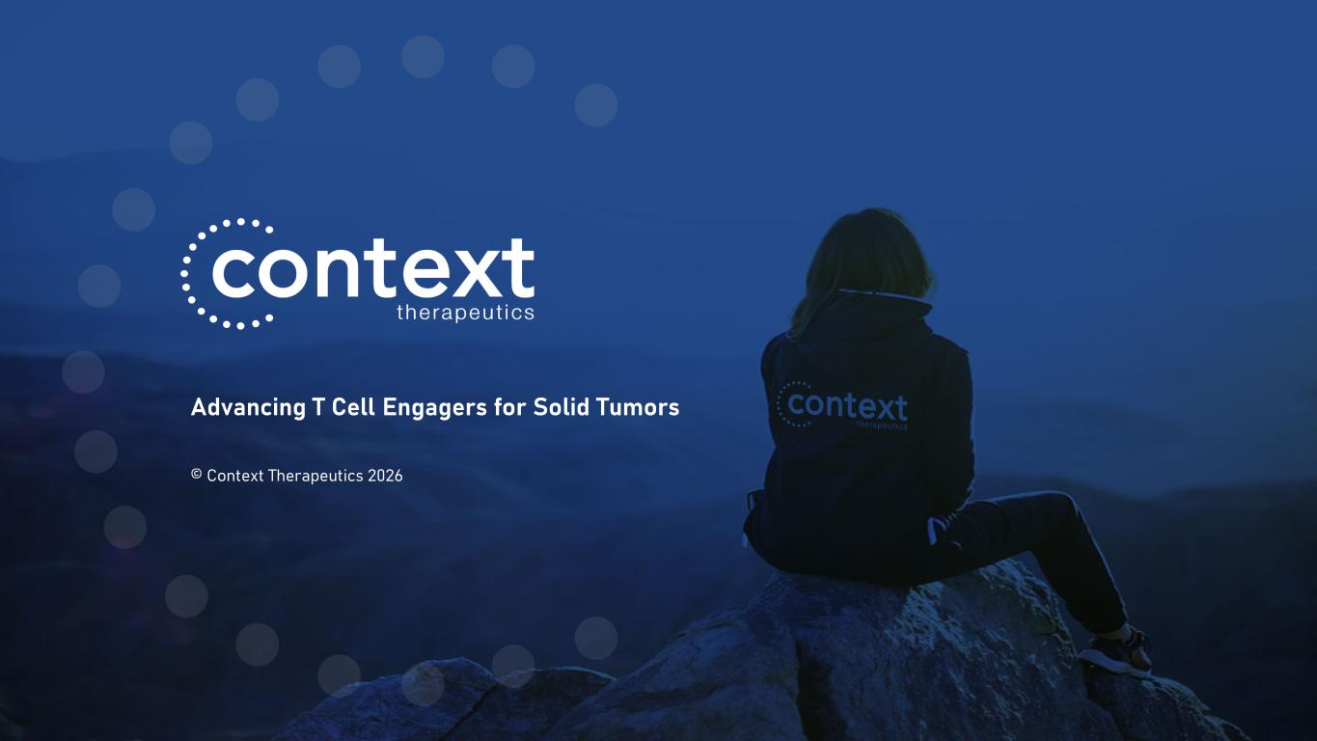
Advancing T Cell Engagers for Solid Tumors © Context Therapeutics 2026

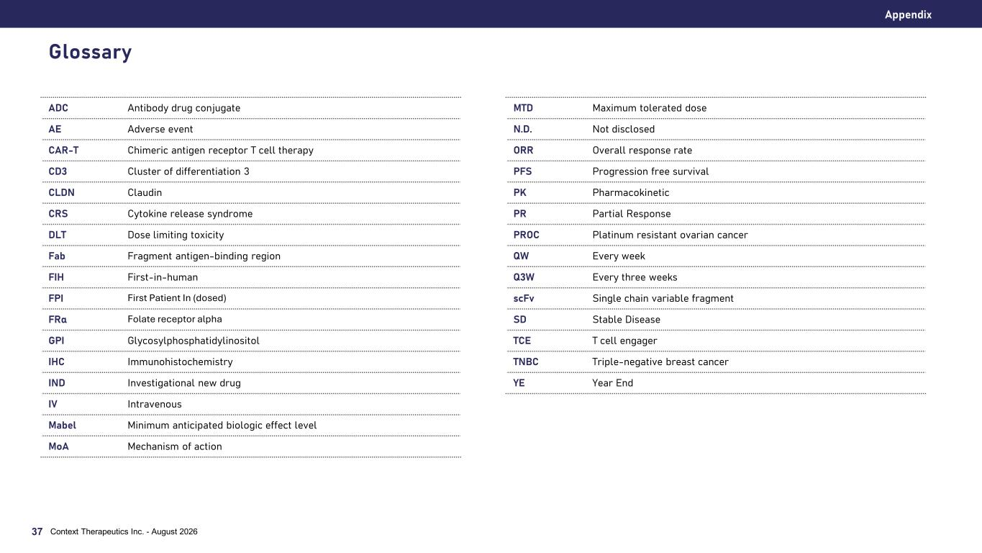
Glossary ADC Antibody drug conjugate AE Adverse event CAR-T Chimeric antigen receptor T cell therapy CD3 Cluster of differentiation 3 CLDN Claudin CRS Cytokine release syndrome DLT Dose limiting toxicity Fab Fragment antigen-binding region FIH First-in-human FPI First Patient In (dosed) FRα Folate receptor alpha GPI Glycosylphosphatidylinositol IHC Immunohistochemistry IND Investigational new drug IV Intravenous Mabel Minimum anticipated biologic effect level MoA Mechanism of action Appendix MTD Maximum tolerated dose N.D. Not disclosed ORR Overall response rate PFS Progression free survival PK Pharmacokinetic PR Partial Response PROC Platinum resistant ovarian cancer QW Every week Q3W Every three weeks scFv Single chain variable fragment SD Stable Disease TCE T cell engager TNBC Triple-negative breast cancer YE Year End Context Therapeutics Inc. - August 202637

